1. Shut down the Raspberry Pi

2. Take the MicroSD card out of the pi, insert it into a microSD card reader, and put it into a Windows computer.

3. You should get the following message. DO NOT CLICK FORMAT. Click cancel

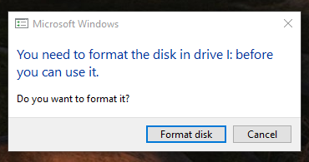

4. Download Win32 Disk Imager from

Orlando Science Center GitHub/exhibits-backup-guide/Raspberry Pi Imaging Guides/Software

It will be win32diskimager-1.0.0-install.exe

5. You can click next until you are through the install for Win32 Disk Imager

6. Once Win32 Disk Imager launches, you should see this screen:

